**Pay and Play Rates**

All Sport Activity bookings* are taken on the hour for a 55minute period. Please see the rates for each activity listed below:

*\*11-a-side is priced per 90minute game and has flexible start times, speak to a member of the team for more information*

Badminton £10 per court/per 55min

Table Tennis £10 per court/per 55min

5-a-side Indoor £40 per 55min

Basketball £40 per 55min

Netball £40 per 55min

Tennis £5.00 per court/per 55min (Free to Leisure Members)

Indoor Tennis £20.00

Bowls £5.00 per 55min (Free to Leisure Members)

11-a-side £60.00 per game

5-a-side Grass £35.00 per 55min

5-a-side Hard Surface £10.00 per 55min

**Equipment for Hire**

Racquet (Tennis & Badminton) £2.50

Tennis Balls (3) £1.00

In/Outdoor Football £3.50

Basketball £3.50

Netball £3.50

Bowls (1 Jack & 4 Woods) £2.50

Padlock (refundable deposit) £5.00

**Equipment for Purchase**

Shuttlecock £1.00

Padlock £5.00

Towel £5.00

MyZone Belt £50.00

Sport Activity Price List

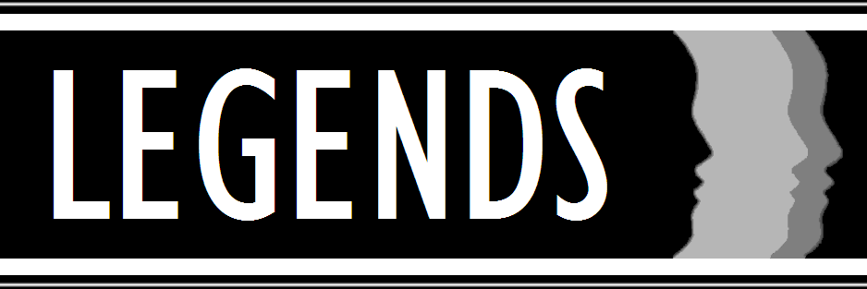

**www.legendsatbentley.com**

Sunnybank Road, Crewe, Cheshire CW2 8WD

Tel: +44 (0) 1270 656868 Email: legends@bentley.co.uk

THE LEISURE AND EVENT VENUE FOR BENTLEY MOTORS